Part A
epochs=3, lr=5e-5, lora_r=8, lora_alpha=16, lora_dropout=0.05
img_name=1
Full Fine-Tune Results:
Test Accuracy: 0.8550
Test F1: 0.8547
Training Time: 54.61s
LoRA Fine-Tune Results:
Test Accuracy: 0.8500
Test F1: 0.8500
Training Time: 51.38s
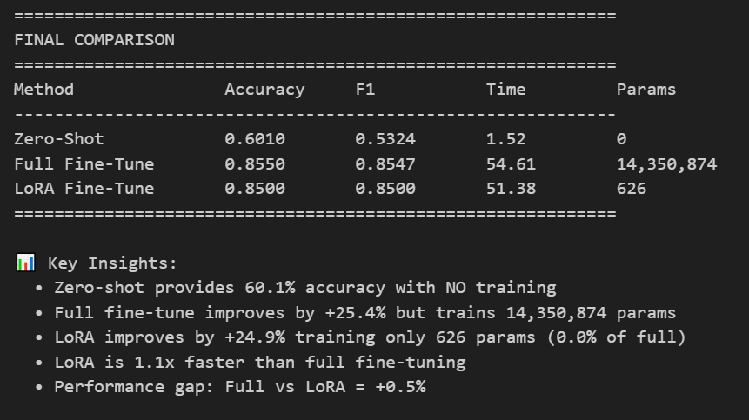
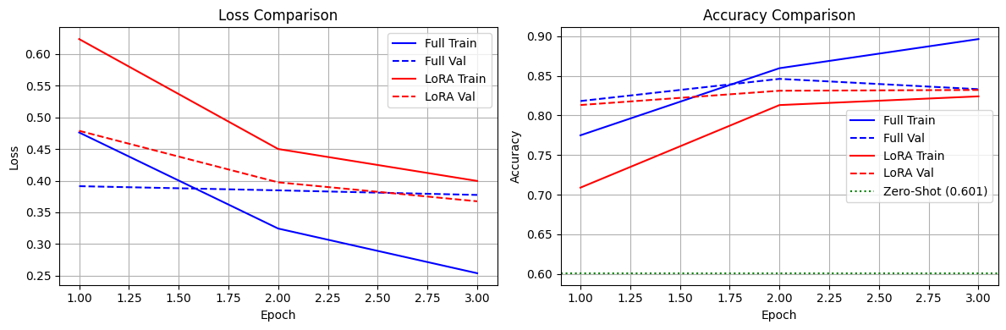
full_size=57432483, lora_size=251465

epochs=5, lr=5e-5, lora_r=8, lora_alpha=16, lora_dropout=0.05
img_name=2
Full Fine-Tune Results:
Test Accuracy: 0.8630
Test F1: 0.8629
Training Time: 92.50s
LoRA Fine-Tune Results:
Test Accuracy: 0.8590
Test F1: 0.8589
Training Time: 85.65s
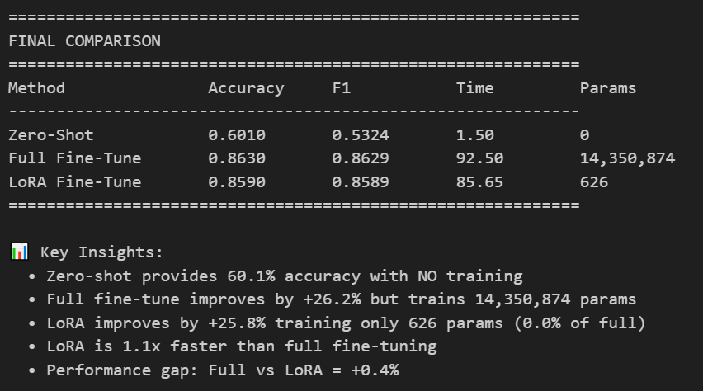
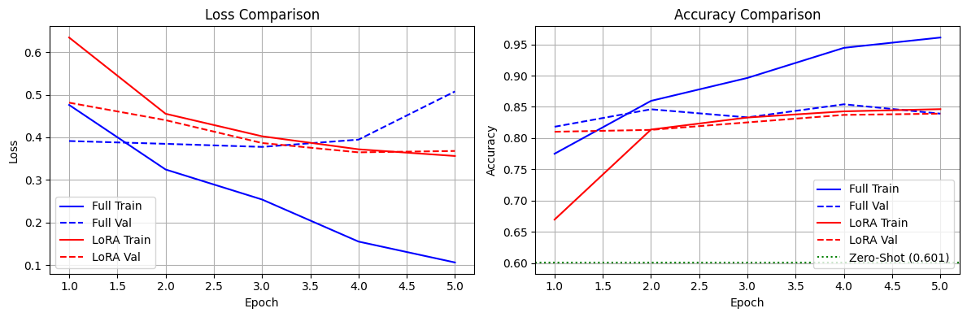
full_size=57432483, lora_size=251465

epochs=8, lr=5e-5, lora_r=8, lora_alpha=16, lora_dropout=0.05
img_name=3
Full Fine-Tune Results:
Test Accuracy: 0.8630
Test F1: 0.8629
Training Time: 146.62s
LoRA Fine-Tune Results:
Test Accuracy: 0.8570
Test F1: 0.8570
Training Time: 136.37s
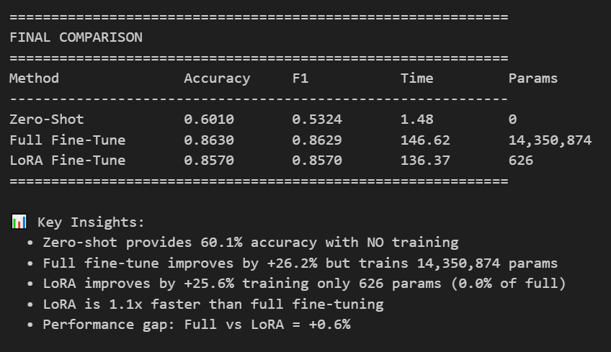
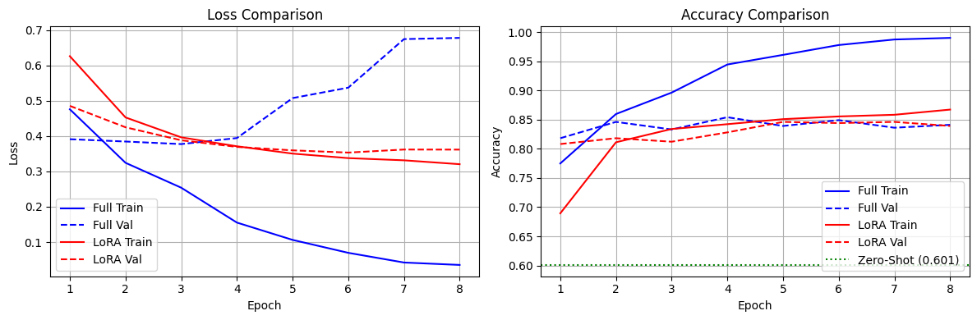
full_size=57432483, lora_size=251465

epochs=5, lr=3e-5, lora_r=8, lora_alpha=16, lora_dropout=0.05
img_name=4
Full Fine-Tune Results:
Test Accuracy: 0.8790
Test F1: 0.8789
Training Time: 91.11s
LoRA Fine-Tune Results:
Test Accuracy: 0.8590
Test F1: 0.8589
Training Time: 85.28s
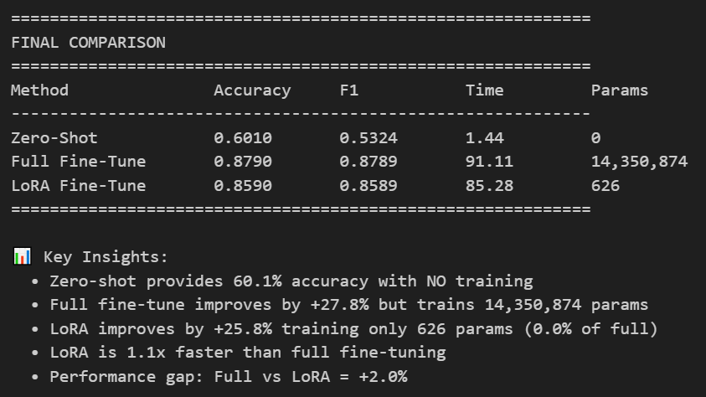
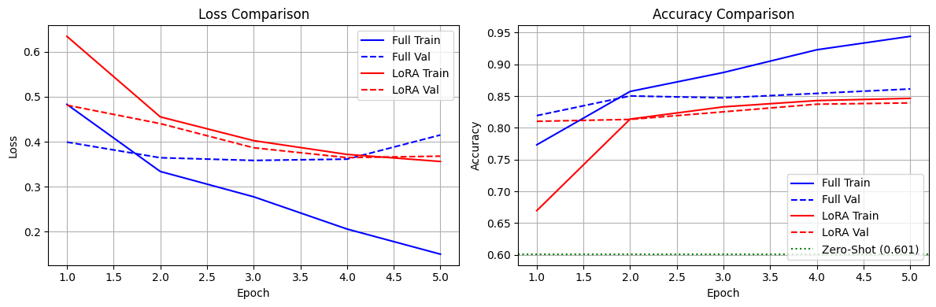
full_size=57432483, lora_size=251465

epochs=5, lr=5e-5, lora_r=8, lora_alpha=16, lora_dropout=0.05
img_name=2
Full Fine-Tune Results:
Test Accuracy: 0.8630
Test F1: 0.8629
Training Time: 92.50s
LoRA Fine-Tune Results:
Test Accuracy: 0.8590
Test F1: 0.8589
Training Time: 85.65s
full_size=57432483, lora_size=251465

epochs=5, lr=1e-4, lora_r=8, lora_alpha=16, lora_dropout=0.05
img_name=5
Full Fine-Tune Results:
Test Accuracy: 0.8730
Test F1: 0.8729
Training Time: 91.46s
LoRA Fine-Tune Results:
Test Accuracy: 0.8590
Test F1: 0.8589
Training Time: 85.17s
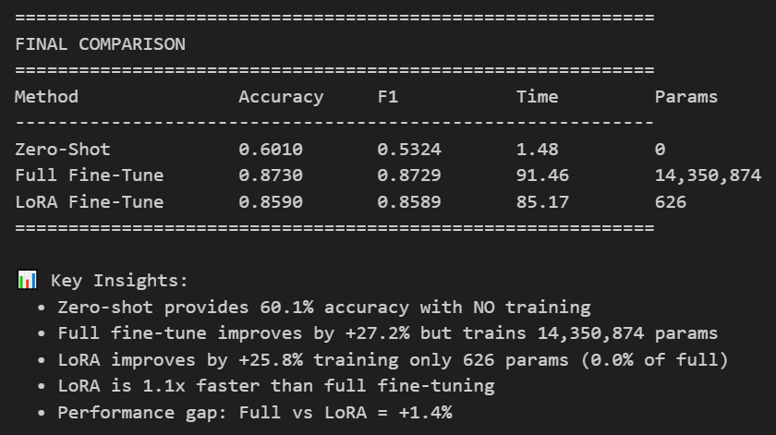
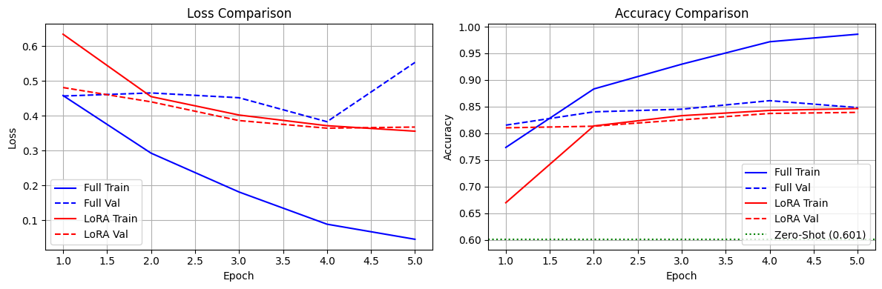
full_size=57432483, lora_size=251465

PartB
epochs=5, lr=3e-5, lora_r=4, lora_alpha=16, lora_dropout=0.05
img_name=6
Full Fine-Tune Results:
Test Accuracy: 0.8790
Test F1: 0.8789
Training Time: 91.02s
LoRA Fine-Tune Results:
Test Accuracy: 0.8470
Test F1: 0.8465
Training Time: 85.31s
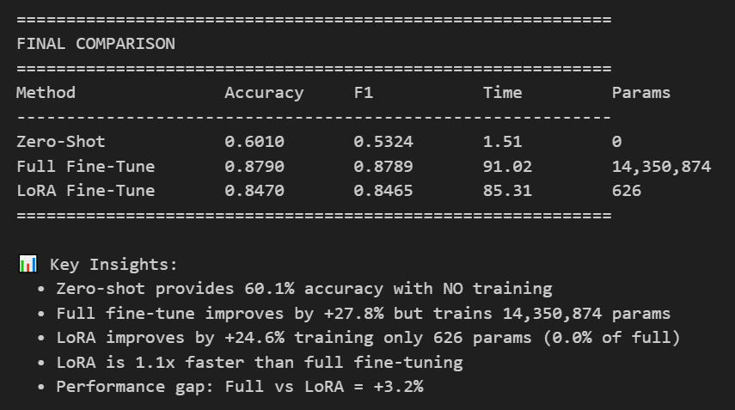
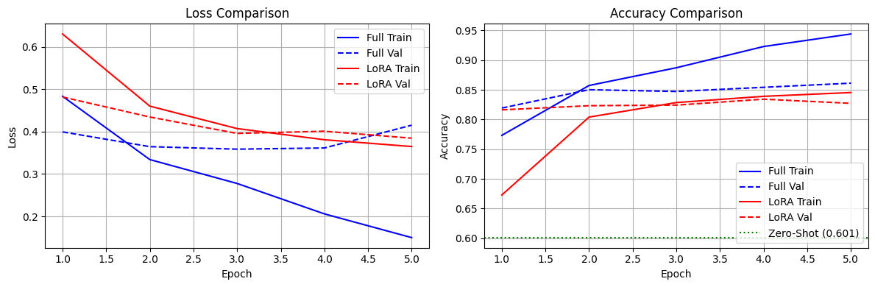
full_size=57432483, lora_size=131641

epochs=5, lr=3e-5, lora_r=8, lora_alpha=16, lora_dropout=0.05
img_name=4
Full Fine-Tune Results:
Test Accuracy: 0.8790
Test F1: 0.8789
Training Time: 91.11s
LoRA Fine-Tune Results:
Test Accuracy: 0.8590
Test F1: 0.8589
Training Time: 85.28s
full_size=57432483, lora_size=251465

epochs=5, lr=3e-5, lora_r=16, lora_alpha=16, lora_dropout=0.05
img_name=7
Full Fine-Tune Results:
Test Accuracy: 0.8790
Test F1: 0.8789
Training Time: 90.79s
LoRA Fine-Tune Results:
Test Accuracy: 0.8480
Test F1: 0.8480
Training Time: 85.42s
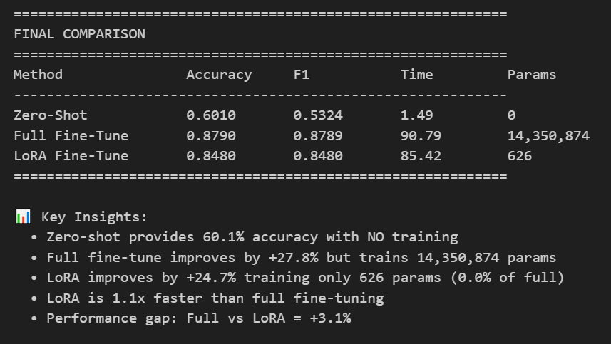
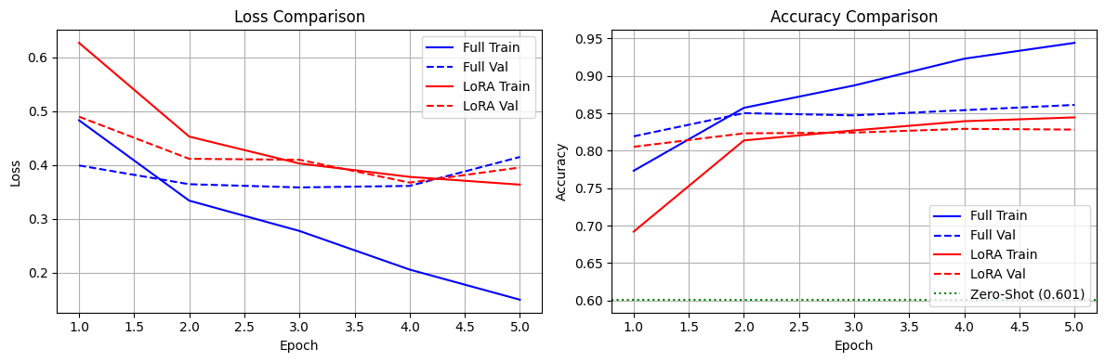
full_size=57432483, lora_size=491122

epochs=5, lr=3e-5, lora_r=8, lora_alpha=8, lora_dropout=0.05
img_name=8
Full Fine-Tune Results:
Test Accuracy: 0.8790
Test F1: 0.8789
Training Time: 90.93s
LoRA Fine-Tune Results:
Test Accuracy: 0.8570
Test F1: 0.8569
Training Time: 84.82s
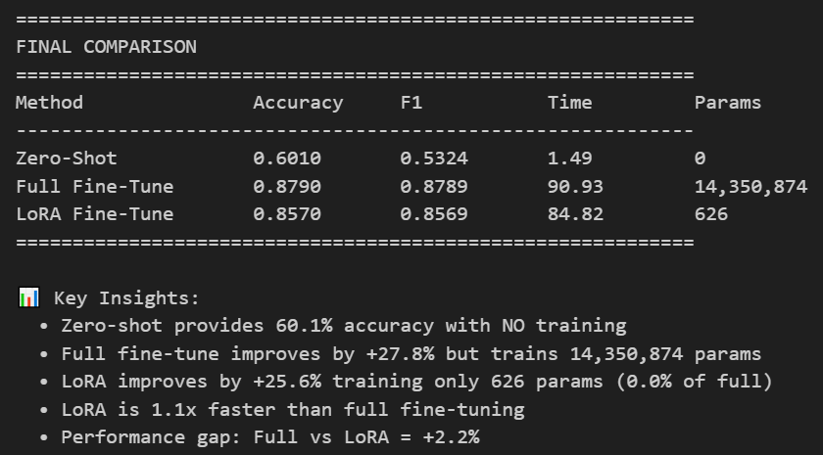
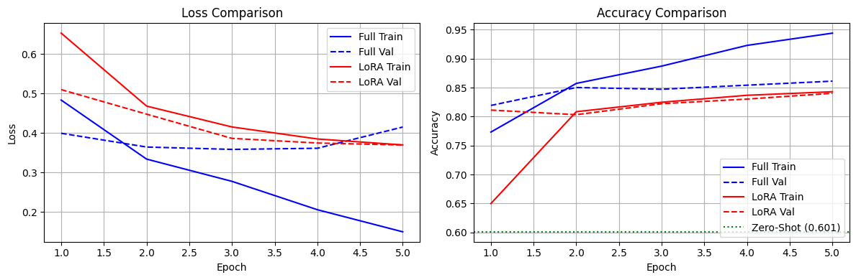
full_size=57432483, lora_size=251464

epochs=5, lr=3e-5, lora_r=8, lora_alpha=16, lora_dropout=0.05
img_name=4
Full Fine-Tune Results:
Test Accuracy: 0.8790
Test F1: 0.8789
Training Time: 91.11s
LoRA Fine-Tune Results:
Test Accuracy: 0.8590
Test F1: 0.8589
Training Time: 85.28s (this is not overfitting)
full_size=57432483, lora_size=251465

epochs=5, lr=3e-5, lora_r=8, lora_alpha=32, lora_dropout=0.05
img_name=9
Full Fine-Tune Results:
Test Accuracy: 0.8790
Test F1: 0.8789
Training Time: 91.02s
LoRA Fine-Tune Results:
Test Accuracy: 0.8590
Test F1: 0.8589
Training Time: 85.13s
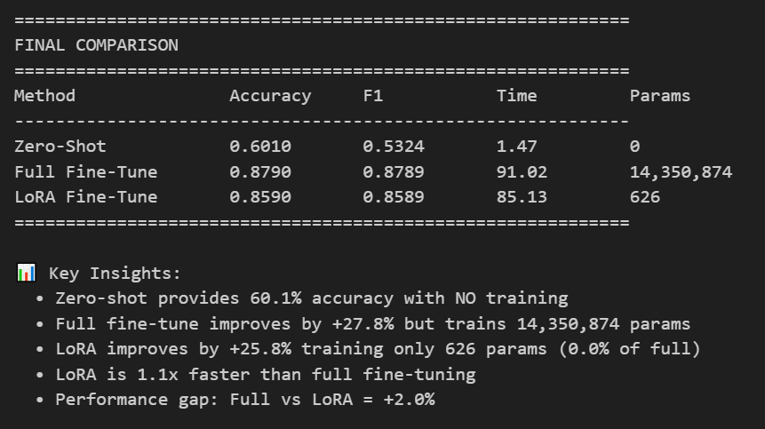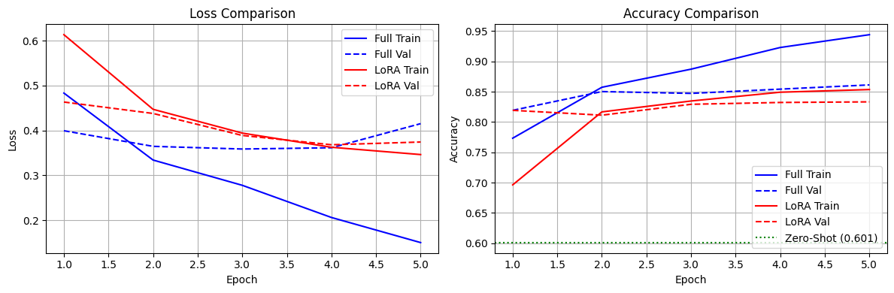
full_size=57432483, lora_size=251465

epochs=5, lr=3e-5, lora_r=8, lora_alpha=16, lora_dropout=0.0
img_name=10
Full Fine-Tune Results:
Test Accuracy: 0.8790
Test F1: 0.8789
Training Time: 90.45s
LoRA Fine-Tune Results:
Test Accuracy: 0.8580
Test F1: 0.8578
Training Time: 84.29s
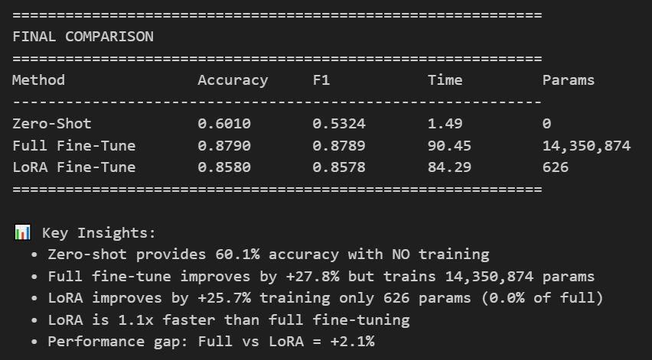
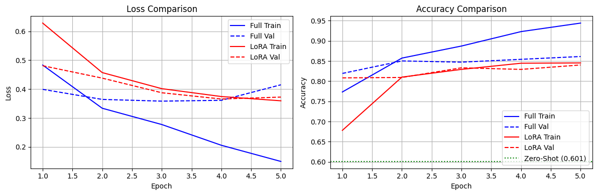
full_size=57432483, lora_size=251464

epochs=5, lr=3e-5, lora_r=8, lora_alpha=16, lora_dropout=0.05
img_name=4
Full Fine-Tune Results:
Test Accuracy: 0.8790
Test F1: 0.8789
Training Time: 91.11s
LoRA Fine-Tune Results:
Test Accuracy: 0.8590
Test F1: 0.8589
Training Time: 85.28s
full_size=57432483, lora_size=251465

epochs=5, lr=3e-5, lora_r=8, lora_alpha=16, lora_dropout=0.1
img_name=11
Full Fine-Tune Results:
Test Accuracy: 0.8790
Test F1: 0.8789
Training Time: 90.55s
LoRA Fine-Tune Results:
Test Accuracy: 0.8550
Test F1: 0.8550
Training Time: 84.93s
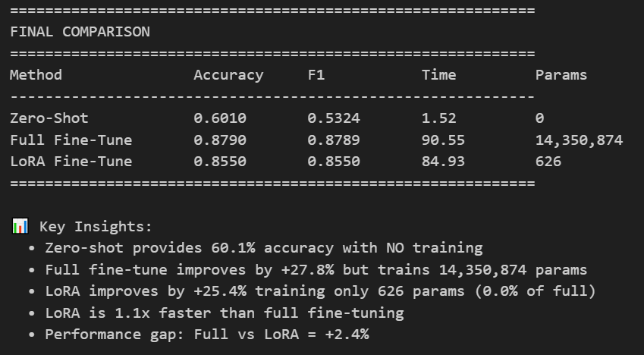
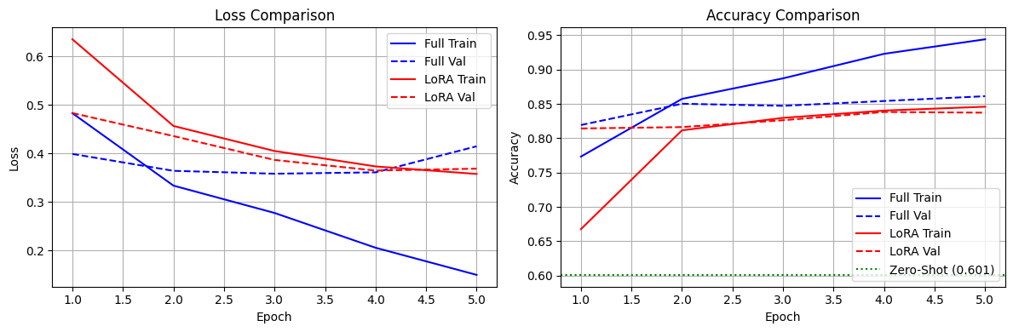
full_size=57432483, lora_size=251464

